# **Introduction:**

Amplitude modulation is one of the important aspects for telecommunication. The invention of amplitude modulation has helped the technology for communication to advance well. It has many uses and is especially important for conversation, signal transmission.

**Amplitude modulation** (**AM**) is a [modulation](https://en.wikipedia.org/wiki/Modulation) technique used in electronic communication, most commonly for transmitting information via a [radio](https://en.wikipedia.org/wiki/Radio) [carrier wave](https://en.wikipedia.org/wiki/Carrier_wave). In amplitude modulation, the [amplitude](https://en.wikipedia.org/wiki/Amplitude) (signal strength) of the carrier wave is varied in proportion to that of the message signal being transmitted. The message signal is, for example, a function of the sound to be reproduced by a [loudspeaker](https://en.wikipedia.org/wiki/Loudspeaker), or the light intensity of pixels of a television screen. This technique contrasts with [frequency modulation](https://en.wikipedia.org/wiki/Frequency_modulation), in which the [frequency](https://en.wikipedia.org/wiki/Frequency) of the [carrier signal](https://en.wikipedia.org/wiki/Carrier_signal) is varied, and [phase modulation](https://en.wikipedia.org/wiki/Phase_modulation), in which its [phase](https://en.wikipedia.org/wiki/Phase_(waves)) is varied.

**Simplified analysis of standard AM Illustration of amplitude modulation**

Consider a carrier wave (sine wave) of frequency fc and amplitude A given by:

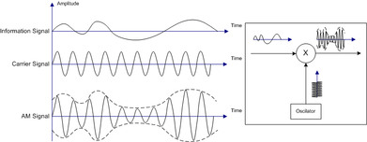

Let m(t) represent the modulation waveform. For this example, we shall take the modulation to be simply a sine wave of a frequency , a much lower frequency (such as an audio frequency) than :

where m is the amplitude sensitivity, M is the amplitude of modulation. If , is always positive for under-modulation. If then overmodulation occurs and reconstruction of message signal from the transmitted signal would lead in loss of original signal. Amplitude modulation results when the carrier is multiplied by the positive quantity:

In this simple case m is identical to the modulation index, discussed below. With m = 0.5 the amplitude modulated signal y(t) thus corresponds to the top graph (labelled "50% Modulation") in figure 4.

Using prosthaphaeresis identities, y(t) can be shown to be the sum of three sine waves:

Therefore, the modulated signal has three components: the carrier wave c(t) which is unchanged, and two pure sine waves (known as sidebands) with frequencies slightly above and below the carrier frequency .

## Spectrum

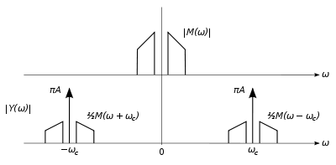

Fig 2: Double-sided spectra of baseband and AM signals.

Of course, a useful modulation signal *m(t)* will generally not consist of a single sine wave, as treated above. However, by the principle of [Fourier decomposition](https://en.wikipedia.org/wiki/Fourier_decomposition), *m(t)* can be expressed as the sum of a number of sine waves of various frequencies, amplitudes, and phases. Carrying out the multiplication of *1 + m(t)* with *c(t)* as above then yields a result consisting of a sum of sine waves. Again, the carrier *c(t)* is present unchanged, but for each frequency component of *m* at *fi* there are two sidebands at frequencies *fc + fi* and *fc - fi*. The collection of the former frequencies above the carrier frequency is known as the upper sideband, and those below constitutes the lower sideband. In a slightly different way of looking at it, we can consider the modulation *m(t)* to consist of an equal mix of positive and negative frequency components (as results from a formal [Fourier transform](https://en.wikipedia.org/wiki/Fourier_transform) of a real valued quantity) as shown in the top of Fig. 2. Then one can view the sidebands as that modulation *m(t)* having simply been shifted in frequency by *fc* as depicted at the bottom right of Fig. 2 (formally, the modulated signal also contains identical components at negative frequencies, shown at the bottom left of Fig. 2 for completeness).

## Power and spectrum efficiency

The RF bandwidth of an AM transmission (refer to Figure 2, but only considering positive frequencies) is twice the bandwidth of the modulating (or "[baseband](https://en.wikipedia.org/wiki/Baseband)") signal, since the upper and lower sidebands around the carrier frequency each have a bandwidth as wide as the highest modulating frequency. Although the bandwidth of an AM signal is narrower than one using [frequency modulation](https://en.wikipedia.org/wiki/Frequency_modulation) (FM), it is twice as wide as [single-sideband](https://en.wikipedia.org/wiki/Single-sideband) techniques; it thus may be viewed as spectrally inefficient. Within a frequency band, only half as many transmissions (or "channels") can thus be accommodated. For this reason analog television employs a variant of single-sideband (known as [vestigial sideband](https://en.wikipedia.org/wiki/Vestigial_sideband), somewhat of a compromise in terms of bandwidth) in order to reduce the required channel spacing.

Another improvement over standard AM is obtained through reduction or suppression of the carrier component of the modulated spectrum. In Figure 2 this is the spike in between the sidebands; even with full (100%) sine wave modulation, the power in the carrier component is twice that in the sidebands, yet it carries no unique information. Thus there is a great advantage in efficiency in reducing or totally suppressing the carrier, either in conjunction with elimination of one sideband ([single-sideband suppressed-carrier transmission](https://en.wikipedia.org/wiki/Single-sideband_suppressed-carrier_transmission)) or with both sidebands remaining ([double sideband suppressed carrier](https://en.wikipedia.org/wiki/Double_sideband_suppressed_carrier)). While these suppressed carrier transmissions are efficient in terms of transmitter power, they require more sophisticated receivers employing [synchronous detection](https://en.wikipedia.org/wiki/Product_detector) and regeneration of the carrier frequency. For that reason, standard AM continues to be widely used, especially in broadcast transmission, to allow for the use of inexpensive receivers using [envelope detection](https://en.wikipedia.org/wiki/Envelope_detector). Even (analog) television, with a (largely) suppressed lower sideband, includes sufficient carrier power for use of envelope detection. But for communications systems where both transmitters and receivers can be optimized, suppression of both one sideband and the carrier represent a net advantage and are frequently employed.

## Modulation index

The AM modulation index is a measure based on the ratio of the modulation excursions of the RF signal to the level of the unmodulated carrier. It is thus defined as:

m= (peak value of signal/a)

where M and A are the modulation amplitude and carrier amplitude, respectively; the modulation amplitude is the peak (positive or negative) change in the RF amplitude from its unmodulated value. Modulation index is normally expressed as a percentage and may be displayed on a meter connected to an AM transmitter.

So, if m = 0.5 , carrier amplitude varies by 50% above (and below) its unmodulated level, as is shown in the first waveform, below. For m = 1.0 , it varies by 100% as shown in the illustration below it. With 100% modulation the wave amplitude sometimes reaches zero, and this represents full modulation using standard AM and is often a target (in order to obtain the highest possible [signal-to-noise ratio](https://en.wikipedia.org/wiki/Signal-to-noise_ratio)) but mustn't be exceeded. Increasing the modulating signal beyond that point, known as [overmodulation](https://en.wikipedia.org/wiki/Overmodulation), causes a standard AM modulator (see below) to fail, as the negative excursions of the wave envelope cannot become less than zero, resulting in [distortion](https://en.wikipedia.org/wiki/Distortion) ("clipping") of the received modulation. Transmitters typically incorporate a [limiter](https://en.wikipedia.org/wiki/Limiter) circuit to avoid overmodulation, and/or a [compressor](https://en.wikipedia.org/wiki/Dynamic_range_compression) circuit (especially for voice communications) in order to still approach 100% modulation for maximum intelligibility above the noise. Such circuits are sometimes referred to as a [vogad](https://en.wikipedia.org/wiki/Vogad).

However it is possible to talk about a modulation index exceeding 100%, without introducing distortion, in the case of [double-sideband reduced-carrier transmission](https://en.wikipedia.org/wiki/Double-sideband_reduced-carrier_transmission). In that case, negative excursions beyond zero entail a reversal of the carrier phase, as shown in the third waveform below. This cannot be produced using the efficient high-level (output stage) modulation techniques (see below) which are widely used especially in high power [broadcast](https://en.wikipedia.org/wiki/Broadcast) transmitters. Rather, a special modulator produces such a waveform at a low level followed by a [linear amplifier](https://en.wikipedia.org/wiki/Linear_amplifier). What's more, a standard AM receiver using an [envelope detector](https://en.wikipedia.org/wiki/Envelope_detector) is incapable of properly demodulating such a signal. Rather, synchronous detection is required. Thus double-sideband transmission is generally *not* referred to as "AM" even though it generates an identical RF waveform as standard AM as long as the modulation index is below 100%. Such systems more often attempt a radical reduction of the carrier level compared to the sidebands (where the useful information is present) to the point of [double-sideband suppressed-carrier transmission](https://en.wikipedia.org/wiki/Double-sideband_suppressed-carrier_transmission) where the carrier is (ideally) reduced to zero. In all such cases the term "modulation index" loses its value as it refers to the ratio of the modulation amplitude to a rather small (or zero) remaining carrier amplitude.

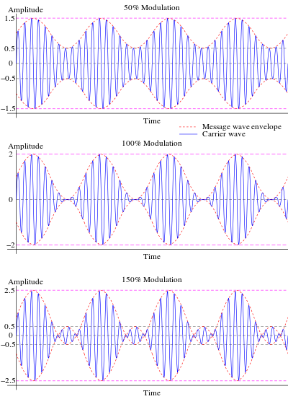

# **Objective:**

The main objective of this experiment is to observe the amplitude modulation of signals using the TIMS model and examine the effect of amplitude modulated signals changing modulation index for the signals.

# **Equipment:**

For the experiment, the following equipment were used:

1. Oscilloscope
2. Adder
3. Variable DC
4. Master Signal
5. Audio Oscillator
6. Multiplier
7. Wires

# **Procedure:**

* 1. First we found all three required modulated signals.
* Set up for the lab. This was done with the completion of steps T1 – T11.

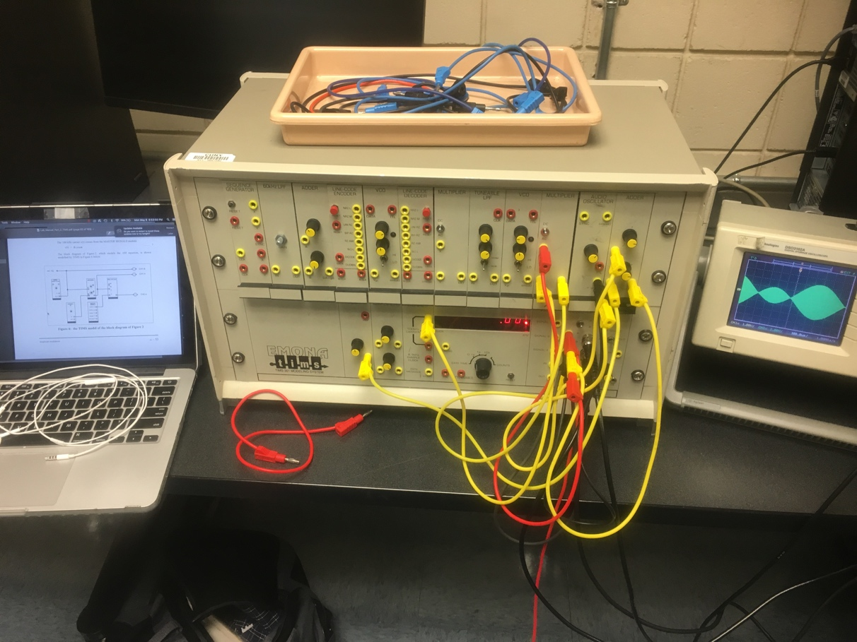

* Over-modulation: . This was the result w/ the completion of step T13.

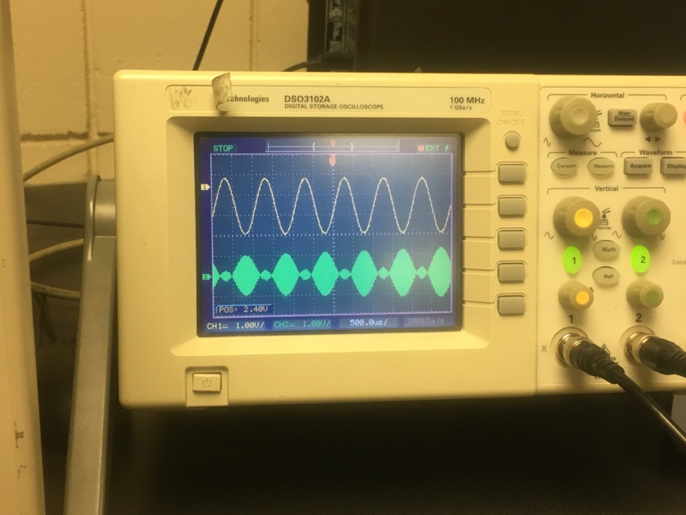

* AM Modulation where m = 1. This was the result w/ the completion of step T14.

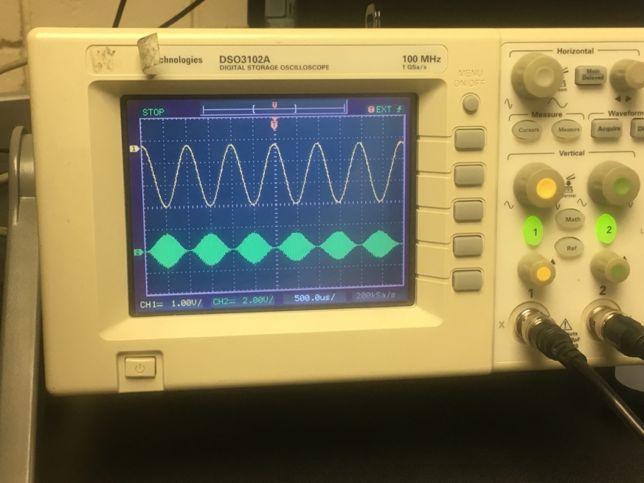

* AM Modulation where m = 0.75. This was the result w/ the completion of step T14..

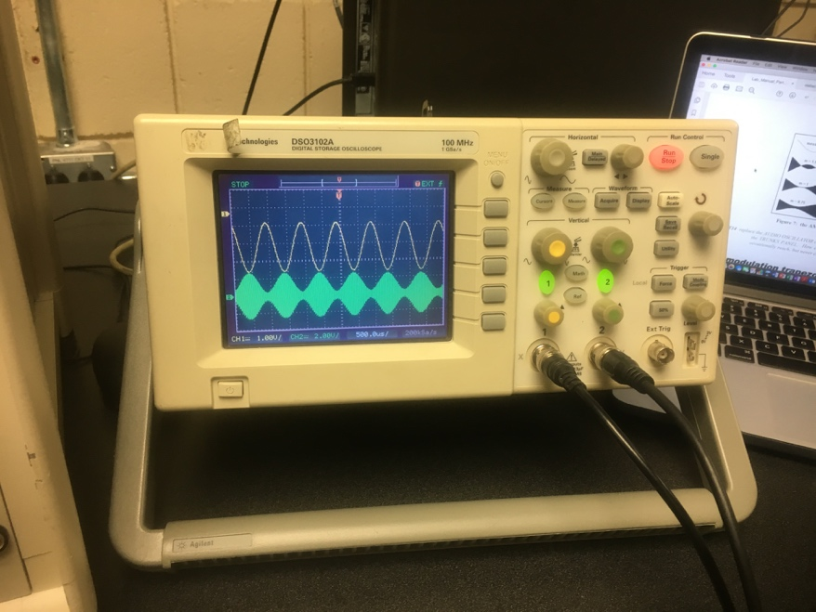

* 1. Now we use the Trapezoidal Display to show more complicated signals such as the ones corresponding to speech. Steps T15 – T19.
* First we have the trapezoidal display where m = 1. This was the result w/ the completion of step T17.

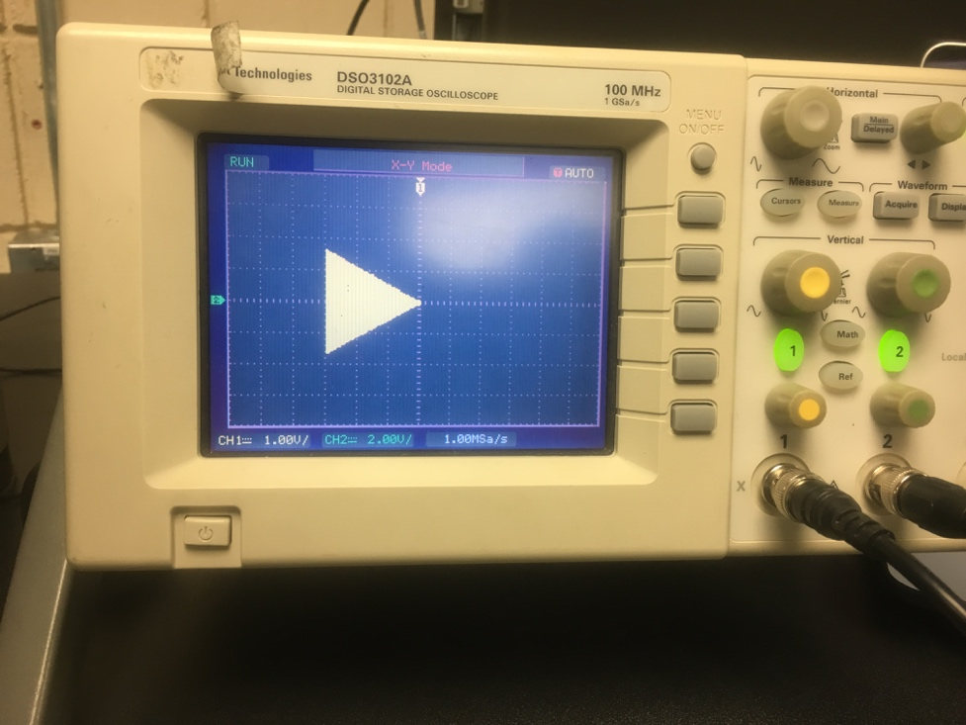

* Then we have the Trapezoidal Display where m > 1 (Over-modulation). This was the result w/ the completion of step T18.

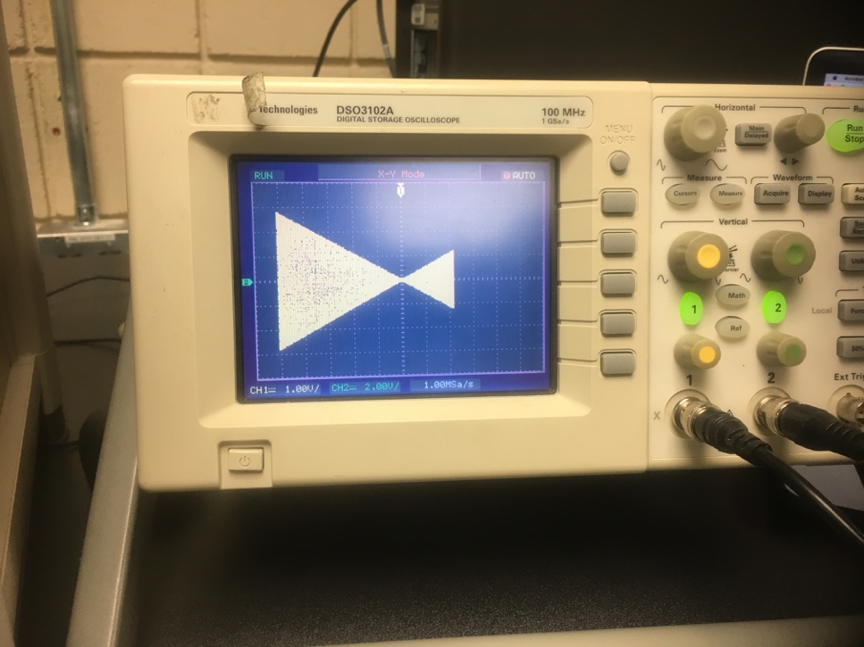

* Last, a Trapezoidal Display for a signal where . This was the result w/ the completion of step T19.

